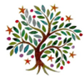**Summer**

Year 5

Dear Parents and carers,

Welcome back for the Summer Term; here is an idea of what we will be learning in Year 5 in our new topic: ‘**Renewable energy.’**

What will we be learning?

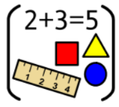

**Maths:** If your child is in Year 5, they will be covering decimals and negative numbers. If your child is in Year 5/6 they will be convering statistics and time timetables.



**English:** we will use the non-fiction text ‘Recycled Planet‘ by Anna Claybourne, we will use this text as inspiration for a formal letter and a webpage.

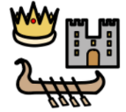

**Geography:** We will explore the question ‘Where does our energy come from?’. We will compare the energy usage in the USA to the UK and look at the positives, and drawbacks, of renewable energy.



**RE:** We will explore Salvation, specifically the question of: What did Jesus do to save human beings?



**Art:**  We will create a collage using recyclable materials.

**PE:** For the first two weeks of the half term we be doing athletics and tennis please remember to wear kit. For the last two weeks we will be going swimming **every afternoon**, children will need to bring their towel and swimming costume/trunks to school every day.

**ICT:** We be looking at the importance of privacy and security online.

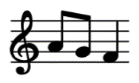

**Music:** We will be starting to learn the songs ready for the performance at the end of summer 2.