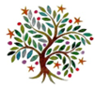**Summer**

Year 6

Dear Parents and carers,

Welcome back for the Summer Term; here is an idea of what we will be learning in Year # and # in our new topic: ‘**Renewable energy.’**

What will we be learning?

**Maths:**

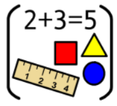We will be revising a range of topics, such as: the four operations, fractions, percentages, statistics, shape.



**English:** We will be revising a range of grammar topics, such as: word class, sentence structure, punctuation types, tenses, standard English, passive/active voice.

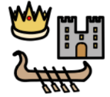

**Geography:**

We will explore the question ‘Where does our energy come from?’. We will compare the energy usage in the USA to the UK and look at the positives, and drawbacks, of renewable energy.

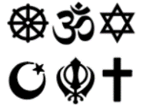

**RE:** We will explore Salvation, specifically the question of: What did Jesus do to save human beings?



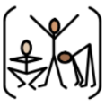**Art:** We will create a collage using recyclable materials

**PE:** This half term we be doing athletics and tennis, please remember to wear kit.

**ICT:** We be looking at the importance of privacy and security online.

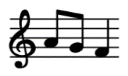

**Music:** We will be starting to learn the songs ready for the performance at the end of summer 2.